Shaun Boerner

Assorted Questions for Algorithms and Data Structures

Q: 2.4.1 Suppose that the sequence P R I O \* R \* \* I \* T \* Y \* \* \* Q U E \* \* \* U \* E (where a letter means insert and an asterisk means remove the maximum) is applied to an initially empty priority queue. Give the sequence of letters returned by the remove the maximum operations.

A: E

Q: 2.4.4 Is an array that is sorted in decreasing order a max-oriented heap?

A: Yes

Q: 2.4.5 Give the heap that results when the keys E A S Y Q U E S T I O N are inserted in that order into an initially empty max-oriented heap.

A: EASYQUESTION

Q: 3.2.1 Draw the BST that results when you insert the keys E A S Y Q U E S T I O N, in that order (associating the value i with the ith key, as per the convention in the text) into an initially empty tree. How many compares are needed to build the tree?

A: 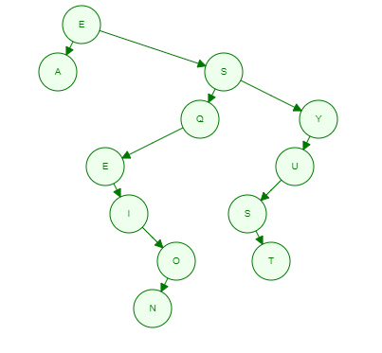It took 26 compares to complete

Q: 3.2.11 How many binary tree shapes of N nodes are there with height N? How many different ways are there to insert N distinct keys into an initially empty BST that result in a tree of height N? (See Exercise 3.2.2.)

A: N-1 shapes with a height of N.

Q: 3.3.1 Draw the 2-3 tree that results when you insert the keys E A S Y Q U T I O N in that order into an initially empty tree.

A: 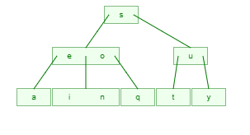

Q: 3.3.2 Draw the 2-3 tree that results when you insert the keys Y L P M X H C R A E S in that order into an initially empty tree.

A: 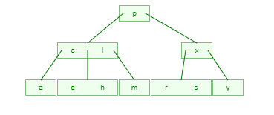

Q: 3.3.10 Draw the red-black BST that results when you insert items with the keys E A S Y Q U T I O N in that order into an initially empty tree.

A: 